**REACT**

**Hands On - 1**

Create a React Application named “cricketapp” with the following components:

1. ListofPlayers

* Declare an array with 11 players and store details of their names and scores using the map feature of ES6
* Filter the players with scores below 70 using arrow functions of ES6.

1. IndianPlayers
   1. Display the Odd Team Player and Even Team players using the Destructuring features of ES6
   2. Declare two arrays T20players and RanjiTrophy players and merge the two arrays and display them using the Merge feature of ES6

Display these two components in the same home page using a simple if else in the flag variable.

App.js

import React from 'react';

import ListofPlayers from './ListofPlayers';

import Scorebelow70 from './Scorebelow70';

import OddPlayers from './OddPlayers';

import EvenPlayers from './EvenPlayers';

import ListofIndianPlayers from './ListofIndianPlayers';

function App() {

const flag = true; // toggle to false to see Odd/Even players

const players = [

{ name: 'Jack', score: 50 },

{ name: 'Michael', score: 70 },

{ name: 'John', score: 40 },

{ name: 'Ann', score: 61 },

{ name: 'Elisabeth', score: 61 },

{ name: 'Sachin', score: 95 },

{ name: 'Dhoni', score: 100 },

{ name: 'Virat', score: 84 },

{ name: 'Jadeja', score: 64 },

{ name: 'Raina', score: 75 },

{ name: 'Rohit', score: 80 },

];

const IndianTeam = [

{ position: 'First', name: 'Sachin1' },

{ position: 'Second', name: 'Dhoni2' },

{ position: 'Third', name: 'Virat3' },

{ position: 'Fourth', name: 'Rohit4' },

{ position: 'Fifth', name: 'Yuvaraj5' },

{ position: 'Sixth', name: 'Raina6' },

];

const T20Players = ['First Player', 'Second Player', 'Third Player'];

const RanjiTrophyPlayers = ['Fourth Player', 'Fifth Player', 'Sixth Player'];

const IndianPlayers = [...T20Players, ...RanjiTrophyPlayers];

if (flag === true) {

return (

<div>

<h1>List of Players</h1>

<ListofPlayers players={players} />

<hr />

<h1>List of Players having Scores Less than 70</h1>

<Scorebelow70 players={players} />

</div>

);

} else {

return (

<div>

<h1>Odd Players</h1>

<OddPlayers IndianTeam={IndianTeam} />

<hr />

<h1>Even Players</h1>

<EvenPlayers IndianTeam={IndianTeam} />

<hr />

<h1>List of Indian Players Merged:</h1>

<ListofIndianPlayers IndianPlayers={IndianPlayers} />

</div>

);

}

}

export default App;

ListofPlayers.js

import React from 'react';

const ListofPlayers = ({ players }) => {

return (

<div>

<ul>

{players.map((player, index) => (

<li key={index}>Mr. {player.name} {player.score}</li>

))}

</ul>

</div>

);

};

export default ListofPlayers;

Scorebelow70.js

import React from 'react';

const Scorebelow70 = ({ players }) => {

const below70 = players.filter(player => player.score < 70);

return (

<div>

<ul>

{below70.map((player, index) => (

<li key={index}>Mr. {player.name} {player.score}</li>

))}

</ul>

</div>

);

};

export default Scorebelow70;

OddPlayers.js

import React from 'react';

const OddPlayers = ({ IndianTeam }) => {

return (

<ul>

{IndianTeam.filter((_, index) => index % 2 === 0).map((player, index) => (

<li key={index}>{player.position} : {player.name}</li>

))}

</ul>

);

};

export default OddPlayers;

EvenPlayers.js

import React from 'react';

const EvenPlayers = ({ IndianTeam }) => {

return (

<ul>

{IndianTeam.filter((_, index) => index % 2 !== 0).map((player, index) => (

<li key={index}>{player.position} : {player.name}</li>

))}

</ul>

);

};

export default EvenPlayers;

ListofIndianPlayers.js

import React from 'react';

const ListofIndianPlayers = ({ IndianPlayers }) => {

return (

<ul>

{IndianPlayers.map((player, index) => (

<li key={index}>Mr. {player}</li>

))}

</ul>

);

};

export default ListofIndianPlayers;

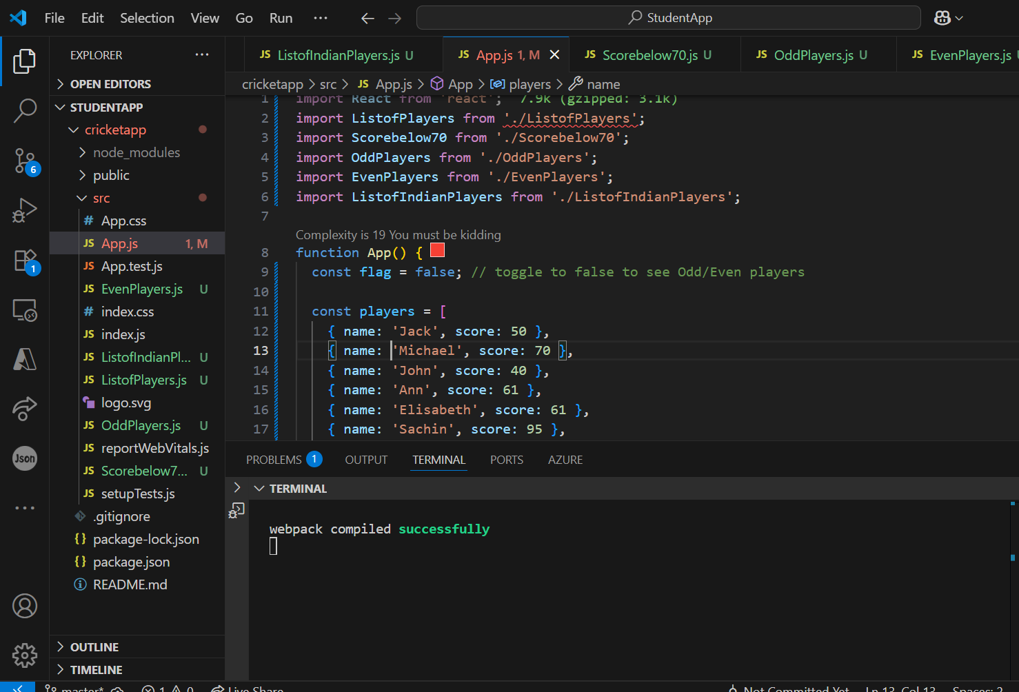

**Output:**

* When Flag= False

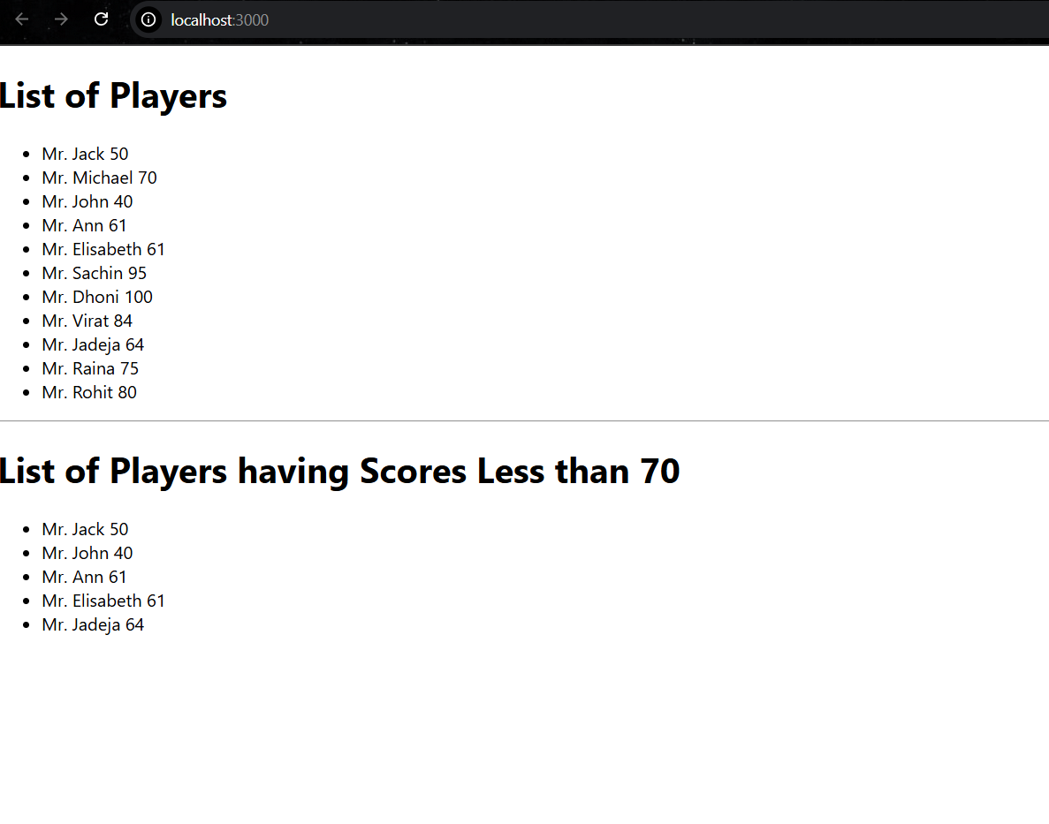

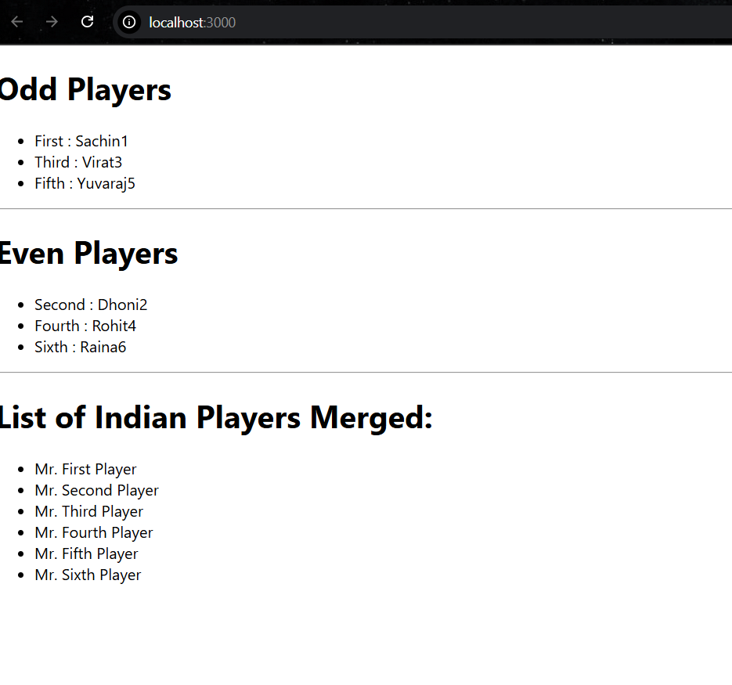

* When Flag= True

